Walk 43 Joyce’s Walk
Last walked in August 2018

Description. Joyce’s Walk is a four-mile (6.4 km) circular walk in the Forest of Dean. It passes thru woods and fields to Hope Mansell, then the walk follows a hilly route to the lane near Horn Hill Farm then skirts Harechurch Wood before returning to the start.
Start. Bailey Lane End. Explorer Map OL14 Grid 643195.
Direction from Belmont roundabout (Turn milometer to zero). Follow the A49 to Ross-on-Wye and at 12.9 miles, at the roundabout you TL towards the M50. TR at the next roundabout (14.3 miles) and onto the A40 for Gloucester. Go straight across the next two roundabouts and continue on the A40 to Gloucester (15.3). At 17.9 miles TR for Drybrook. At 19.6 miles you park off the road, on the R hand side, opposite the road junction to Mitcheldean.

1. Barrier. Climb over the stile, or cross over the forestry barrier and walk straight into the wood for about 50m. At this point five tracks meet, including the one you are on. Take the second track on the L. A little further on this track splits and you take the L hand fork, which goes down hill, (it is the only one that goes downhill). Follow the track downhill thru the conifer woodland. At the foot of the slope the track bears R and runs parallel to a small brook (Bailey Brook) on your L. Further on you join a wide track/drive coming up from the L, you continue around to the R. Pass a holiday cottage on the L called Oak Tree, and when you reach a T-junction you TL. A little further on you reach the post for Bailey Brook and Lilley Cottages (L) where you TL and go down hill, (you will be following the Red way markers for Hope Mansell). Pass a white cottage on the R, and continue on down to go to the R hand side of another cottage called ‘Bailey Brook Cottage. Continue to descend the path to a stile and a small bridge over the stream. After crossing the bridge go straight ahead, with the stream to your R, for about 50m and cross another small stream by an earth bridge. You are now at the foot of a short, but steep, hill with a fence and stile on the skyline. Climb the short hill and cross a stile into another field.

2. Style. Go straight across this field and cross a stile in the hedge to descend the steps onto a lane. You have now reached the village of Hope Mansell and are standing outside the Old School House and the small village hall, both on the L. Continue down the lane to meet a T-junction, immediately opposite is a prominent display cabinet containing information about the walks in and around Hope Mansell, TL. Walk up the lane for about 150m to St Michael’s Church on the L. St Michael’s is a very attractive stone church, probably built in the 12th or 13th century. According to the information in the church, existing Registers of Births, Marriages and Deaths date from 1556 and it is interesting to note that English replaced Latin from about 1590. Other fascinating facts reveal that the font is about 700 years old and, “the sturdy rafters have survived six centuries”. Continue up the lane for about 400m to where a finger post points to the R up a short lane where two five-bar metal gates can be seen. Go up the lane and thru the gate to the R. Continue up the steep-sided lane, emerging into a field, with good views over Hope Mansell to your R.

3. L Hedge. TL and follow the hedge on your L as it curves up the field. Head towards a prominent five-bar gate with a new pedestrian gate alongside it. Go thru the pedestrian gate and continue up the field close to the fence with woodland on your R. Keep close to the woodland and pass under low hanging tree branches. When you are nearing the top of the slope you TR thru a small metal gate and go across a small field to pass thru another small metal gate into a field. Head slightly L to cross a stile onto a lane at a T-junction. There is a cottage called High Stones on the junction. At the junction you TL and go down the lane towards Hope Mansell, (going past the cottage on your R). The lane goes down quite steeply. Walk for about 200m down the hill until you reach a bench seat (donated by M F Freeman) on the L. From this seat you can see virtually the whole of the route so far.
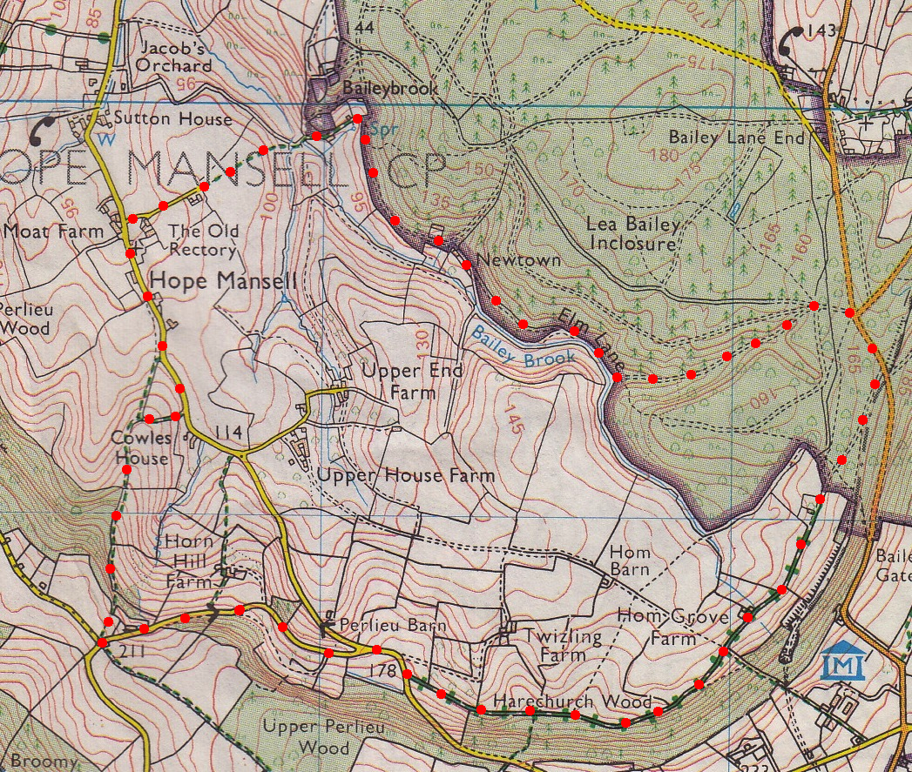
4. Seat Donated by M F Freeman. Continue downhill and along the lane for about 700m, passing the entrance to Horn Hill Farm to reach the road junction where you TR for Drybrook. The lane goes slightly uphill and after a short distance you pass the drive entrance to Twizling Farm on the L, and 30m further on you TL onto an enclosed byway, (the byway sign is tight against the fence on the L and easy to miss). Continue along the byway and as you emerge from woodland you will arrive onto an open lane at Hom Grove Farm. TR and walk almost a km along the track and, just before reaching the road, pause to admire one of the bridges over one of the many disused railway lines in the Forest of Dean. Where the track meets the road, turn L and walk, with care as the traffic travels very quickly, back to the start.
4
3
2
1

